Data loaded from the copies embedded in this script (no upload, no internet needed).
{'weekly_by_state': '492,131 bytes', 'weekly_national': '12,044 bytes', 'season_summary': '10,981 bytes', 'state_metadata': '1,156 bytes'}
numba: True
[data loaded: 1.2s | total 1.2s]
Loaded 74 saved fits (paper parameters).
[fitting / loading fits (incl. numba compile): 0.1s | total 1.3s]
In-sample fit: mean MAPE 28.8% | median 27.0% (74 state-seasons)
[pooling: 1.2s | total 2.5s]
[300 simulated trajectories per state: 0.3s | total 2.8s]
Outcome cascade: h = 0.00771 + 0.01225*access (R2=0.758); CFR logistic R2=0.953, params=[0.0358 0.3 5.1469 0.3326]
[outcome cascade: 0.1s | total 2.9s]

=== TABLE 3: seasonal targets, Nigeria (blind forecast vs actual, 2025/2026) ===
Target Forecast Actual Error
Peak week 15 15 0 weeks
Peak incidence 3,096,549 3,583,057 13.6%
Cumulative cases 21,877,139 22,239,254 1.6%
Seasonal attack rate (%) 9.53 9.69 0.16 pp
Cumulative hospitalisations 324,417 327,633 1.0%
Cumulative deaths 31,168 30,603 1.8%

=== TABLE 4: evaluation metrics (MAE, RMSE, CRPS, WIS, mean quantile loss, interval coverage) ===
MAE RMSE CRPS WIS Mean QL Cov90 % Cov50 %
Nigeria cases 153,230.00 294,502.00 106,754.00 95,653.00 52,976.00 90.00 42.00
North cases 88,534.00 181,374.00 63,930.00 56,213.00 31,127.00 90.00 42.00
South cases 76,680.00 186,331.00 52,085.00 45,581.00 25,043.00 90.00 48.00
Hospitalisations (national) 2,300.00 4,239.00 1,579.00 1,407.00 781.00 90.00 42.00
Deaths (national) 219.00 434.00 156.00 137.00 76.00 90.00 35.00

=== TABLE 6: seasonal targets by region ===
Region Attack rate f/a (%) Cum. cases err Cum. hosp err Cum. deaths err Peak wk f/a Peak inc. err
Nigeria 9.53 / 9.69 1.6% 1.0% 1.8% 15 / 15 13.6%
North 9.46 / 9.06 4.4% 1.3% 4.5% 17 / 17 19.4%
South 9.57 / 10.48 8.7% 3.3% 4.7% 15 / 15 27.9%

=== TABLE 7: state-level performance across 37 states (mean / median / lowest / highest) ===
Mean Median Lowest Highest
MAE 5,412.60 4,767.50 1,476.60 19,686.90
relWIS 30.10 29.50 21.00 43.30
cov90 88.50 88.50 67.30 94.20
cov50 48.30 50.00 19.20 65.40
pw_err 0.60 1.00 0.00 2.00
ar_err 1.30 1.00 0.00 5.40
cum_err 13.70 9.40 0.20 54.80
hosp_err 11.90 10.00 0.30 34.30
death_err 13.30 11.90 0.00 41.90
Worst cumulative-case error: Gombe (54.8%); lowest 90% coverage: Kano (67.3%)

=== OPTIONAL TARGETS (national) ===
P(transmission increasing vs prior week): {14: '99%', 15: '89%', 16: '43%', 17: '4%', 18: '0%', 19: '0%'}
P(transmission decreasing vs prior week): {17: '96%', 18: '100%', 19: '100%', 20: '100%', 21: '99%', 22: '82%'}
P(epidemic peak falls in weeks 13-17): 100%
Quantile forecast, national cases at week 15: {'10th': '1,587,203', '25th': '2,171,487', '50th': '2,913,310', '75th': '3,867,598', '90th': '5,108,121'}
[tables: 0.4s | total 3.2s]
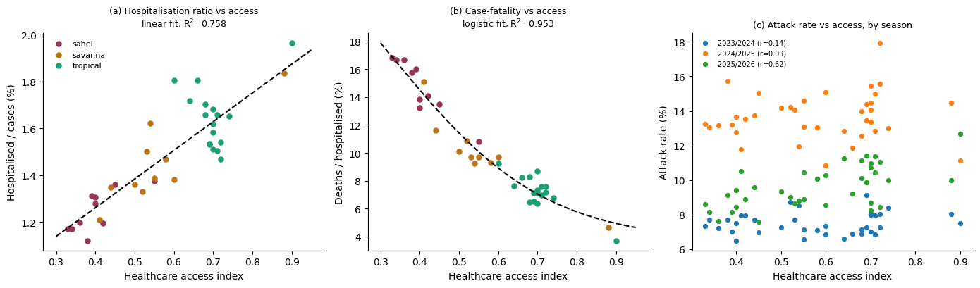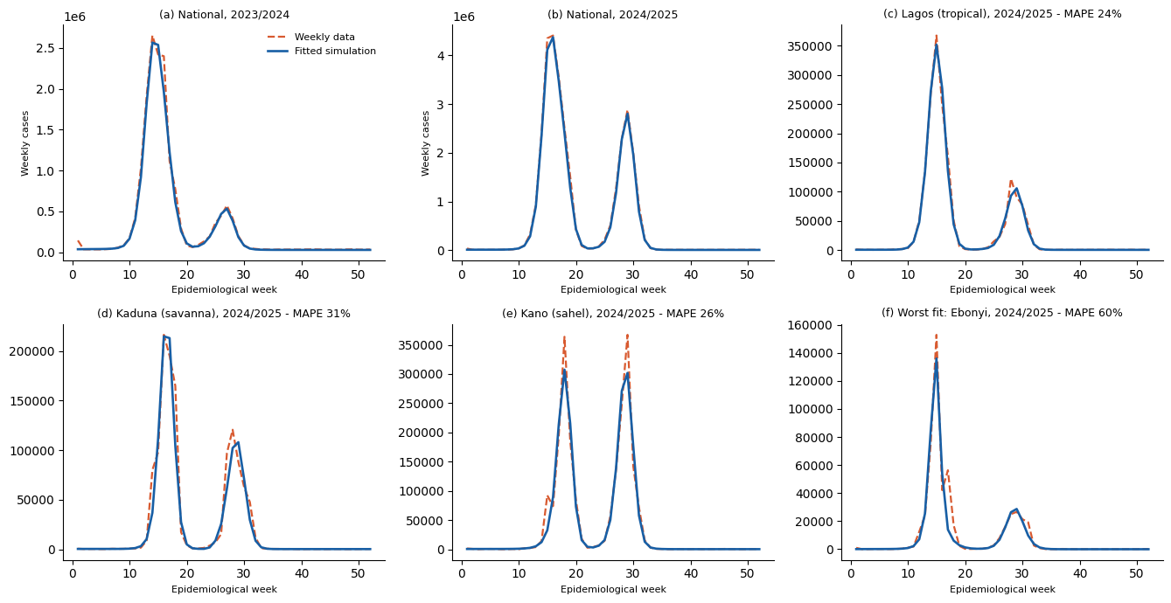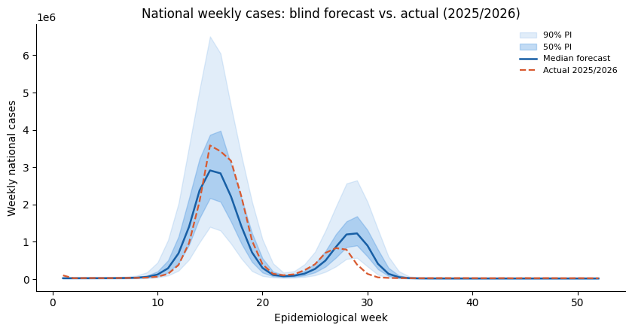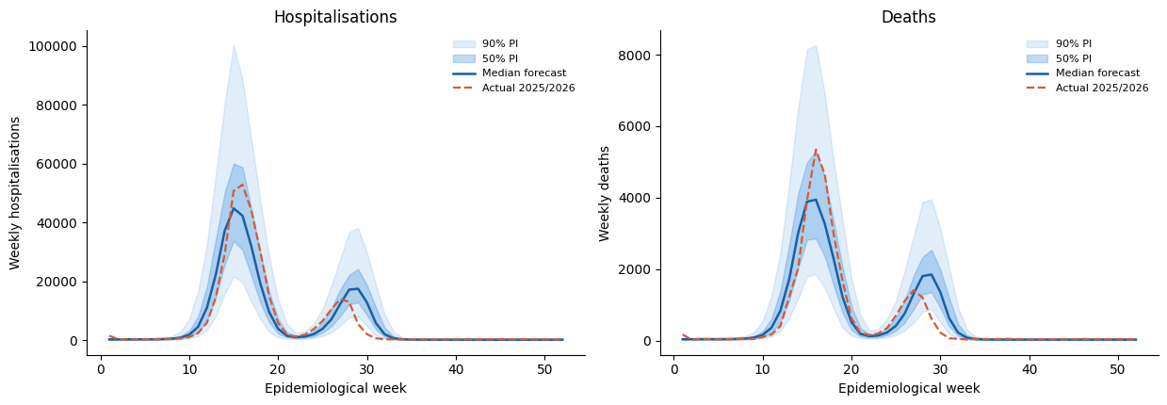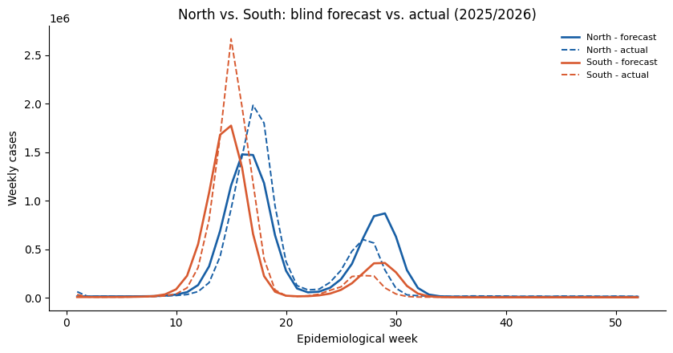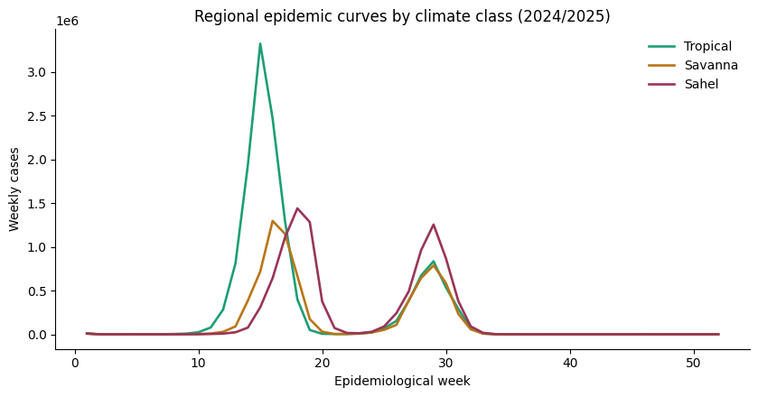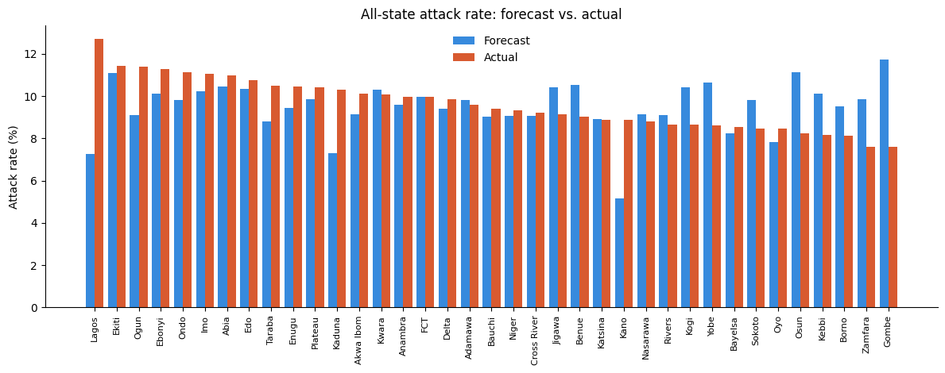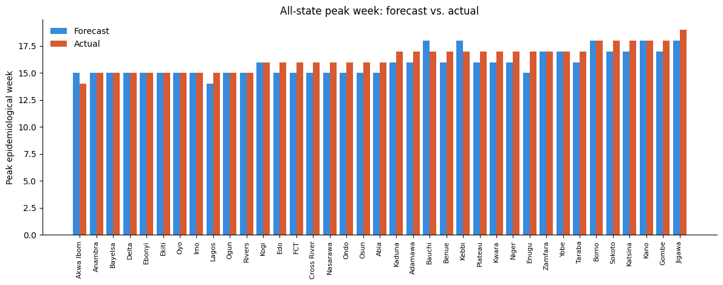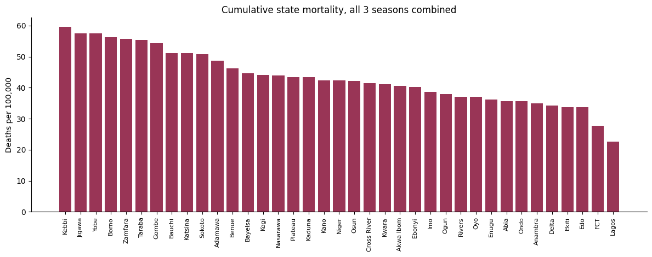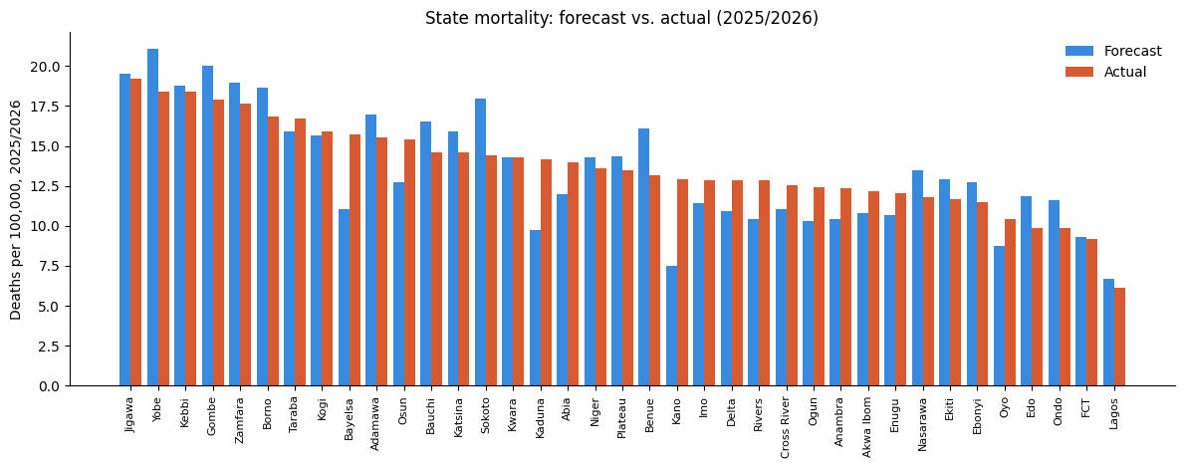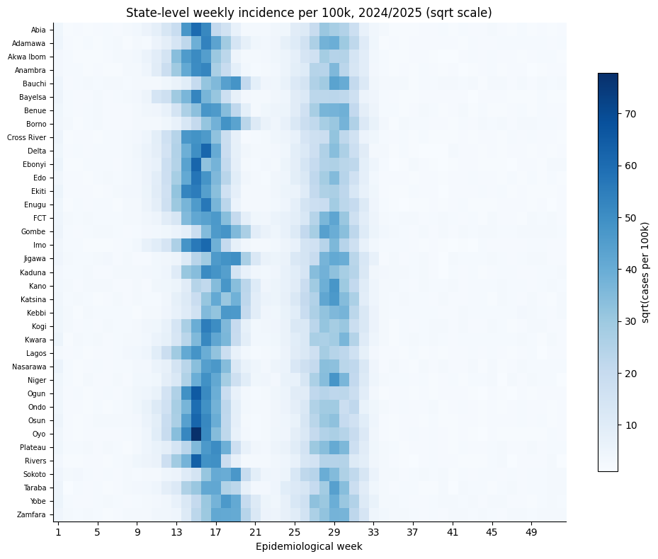 [figures: 6.2s | total 9.4s]

Done in 9s. 11 figures saved in 'figures_out/' and zipped as cpd_hseir_figures.zip

